Name and surname | Siviwe Ndaliso
Student Number | ST10521956
Subject Code | WEDE5020
Qualification | BACHELOR OF IT IN BUSINESS MANAGEMENT
Module | WEB DEVELOPMENT
Group | GROUP 4

Table of contents

Contents
-PROPOSAL CONTENT Kpop Retail Store 2
1.Organisation Overview 2
2. Website Goals and Objectives 2
3. Current Website Analysis 2
4. Proposed Website Features and Functionality 3
5. Design and User Experience 3
6.Technical Requirements 3
7. Timeline and Milestones 3
8. Budget 3
9. References 4

chosen web proposal ~ k-pop retail store (VIWEWAVE)

PROPOSAL CONTENT K-pop Retail Store

Github repo link : https://github.com/Siviwe-Ndaliso/ViweWave-WEBSITE

1.Organisation Overview
ViweWave, established in 2026, sells authentic K-pop merchandise, including albums, clothing, and accessories. It serves teens and global fans, offering both online and in-store shopping while building a vibrant fan community.

2. Website Goals and Objectives
The main objective of the website is to create a fan orientated community, display quality products and increase profitability. Goals include:
- Providing a smooth online shopping experience with secure payment options.
- Displaying products with high quality images, descriptions and prices.
- Promoting upcoming
- Newsletter sign-ups for fan updates and promotions
KPIs
- Number of online sales
- Website traffic
- Customer engagement

3. Current Website Analysis
ViweWave K-pop Shop is newly founded and has no existing website; it currently depends on social media for product promotion. Creating a website will allow the store to reach a bigger audience, display merchandise, and provide a convenient platform for K-pop fans to browse and buy products.

4. Proposed Website Features and Functionality

- Homepage ~ featured products, new releases, and promotions.
- Shop Page ~ categorised merchandise with filtering options (albums, light sticks, clothing, accessories)
- Product Pages ~ detailed product info with high quality images and reviews
- Shopping Cart and Checkout ~ secure payment integration for multiple payment methods
- Events and News Section ~ customer service information and inquiry form

5. Design and User Experience
The website will have a visually vibrant and trendy design reflecting the energy of K-pop culture.
- Colour Scheme: Neon pink, black and white for a modern and vibrant vibe.
- Typography: Bold, readable fonts that match K-pop aesthetics
- Layout: Image focused with easy navigation
- Mobile friendly design: Optimised for smartphones, most fans use mobile devices.
- Performance: Fast loading speed and intuitive user experience to keep fans engaged

6.Technical Requirements
The website requires a computer, internet, development tools Visual studio code , hosting, and a domain with SSL security.

Github repo screenshot
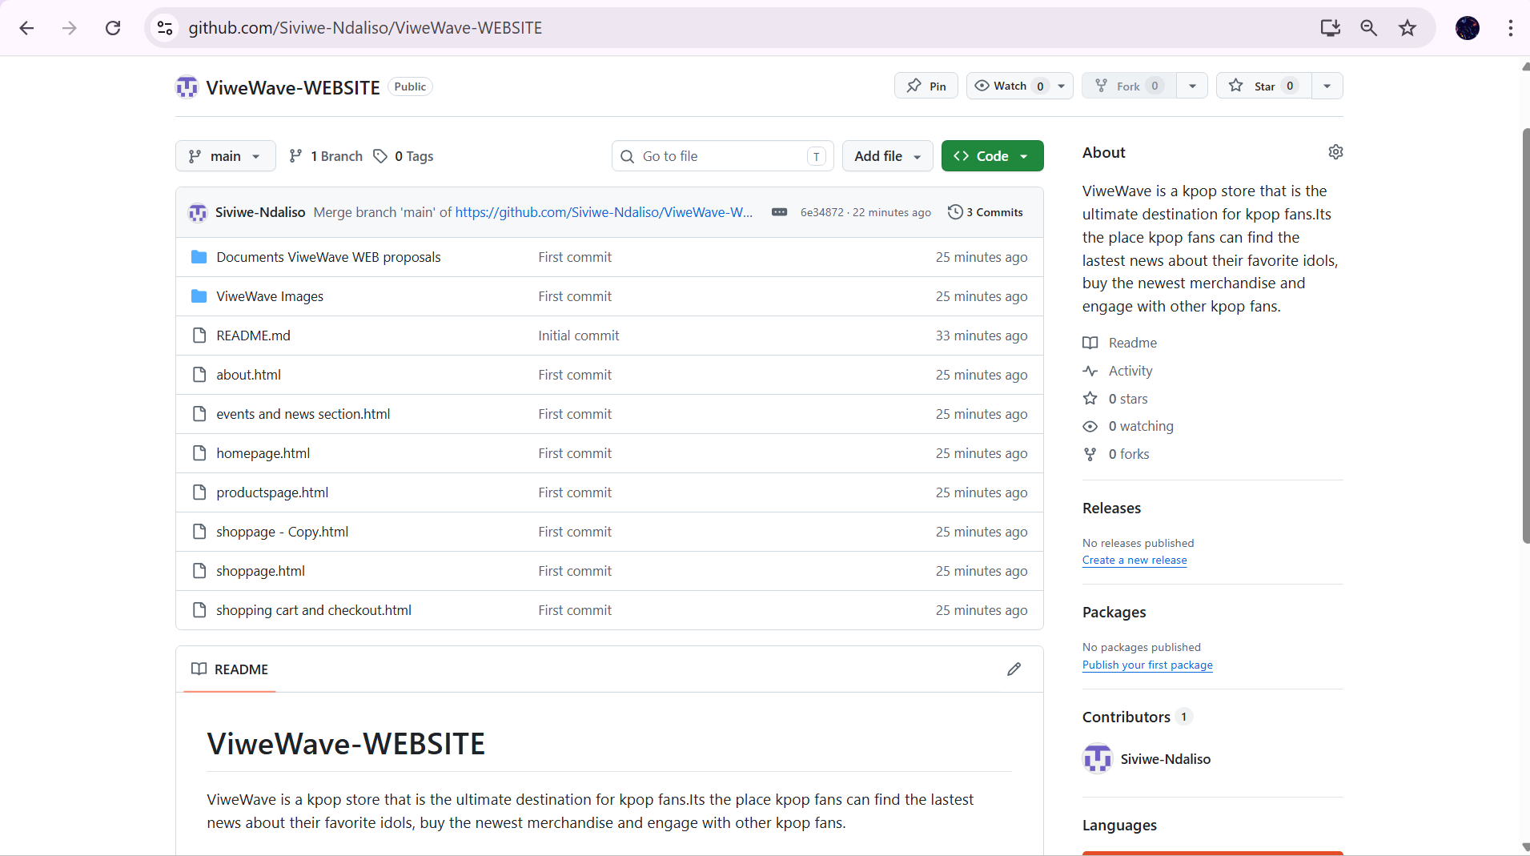

7. Timeline and Milestones
The project will take approximately six weeks. This includes planning, design, development, testing, and final launch of the website, followed by minor updates after release.

8. Budget
The estimated costs range from R10 000 – R150 000 for development, and for monthly ongoing costs it ranges between R500 – R5000 for hosting and maintenance. Domain registration ranges between R100 – R300 per year.

9. References
- OpenAI.2026. ChatGPT (GPT-5.3). Available at: https:// chat. OpenAI/ (Accessed: 31 March 2026).
- Growth Pulse Media .2026. Web design pricing South Africa: Complete cost guide 2026. Available at: Web design pricing South Africa (Accessed: 31 March 2026)

1. My own code
The navigation bar was created using HTML(own work, 2026)

2. Website Sources (HTML/CSS/JS help)
Mozilla. (2025) HTML: HyperText Markup Language. Available at: https://developer.mozilla.org/en-US/docs/Web/HTML (Accessed: 14 April 2026).
W3Schools. (2025) HTML Tutorial. Available at: https://www.w3schools.com/html/ (Accessed: 20 April 2026).

3. GitHub Code Source
freeCodeCamp. (2024) Responsive Web Design Projects. Available at: https://github.com/freeCodeCamp/freeCodeCamp (Accessed: 17 April 2026).

4. AI / ChatGPT Assistance
OpenAI. (2026) ChatGPT assistance on web development and coding support. Available at: https://chat.openai.com (Accessed: 15 April 2026).

5. Images (Pinterest)
Pinterest. (n.d.) Aesthetic K-pop wallpaper images. Available at: https://www.pinterest.com/ (Accessed: 16 April 2026).
Pinterest. (n.d.) Website design inspiration images. Available at: https://www.pinterest.com/ (Accessed: 16 April 2026).

